Practical 3 Basic I/O Programming in Unix
Here are clear and concise answers to your 10 Unix-related questions:

1. How do you get a list of all processes running on your computer?
Use the ps or top command:
ps aux or top

2. What symbols are used to represent:
- The root directory: /
- Your home directory: ~
- The current directory: .

3. What is $PATH?
$PATH is an environment variable that contains a list of directories that the shell searches through to find executable files when you type a command.
To view it:
echo $PATH

4. How do you get the full pathname of your current directory?
Use the pwd (print working directory) command:
pwd

5. What is a command shell program?
A command shell is a program that interprets and runs commands entered by the user. It provides a command-line interface to the operating system (e.g., bash, zsh, sh).

6. How do you run a command in parallel with the shell process (background)?
Add an & at the end of the command. For example:
gedit &

7. How do you redirect the output of a process to a file?
Use the > operator. For example:
ls > filelist.txt
To append instead of overwrite, use >>:
ls >> filelist.txt

8. How do you pipe the output of one process into another?
Use the | (pipe) operator. For example:
ls | grep ".txt"

9. What is a shell script?
A shell script is a text file containing a sequence of shell commands. It can be executed like a program to automate tasks.
Example:
#!/bin/bash
echo "Hello, World!"

10. How do you pass arguments to a script?
Arguments are passed after the script name and accessed using $1, $2, etc., inside the script.
Example:
./myscript.sh arg1 arg2
Inside myscript.sh:
echo "First argument is $1"
echo "Second argument is $2"

Let me know if you'd like these as a printable cheat sheet or an interactive quiz!

cc p3a.c -o p3a # x = a, b, c, d, e, f
./p3a #
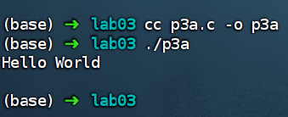

cc p3b.c -o p3b
./p3b

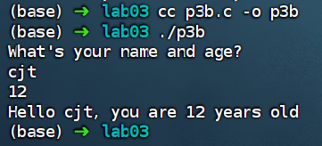

cc p3c.c -o p3c
./p3c
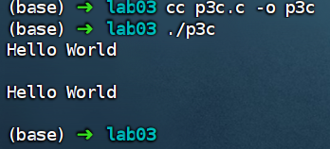

cc p3d.c -o p3d
./p3d

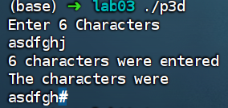

cc p3e.c -o p3e
./p3e
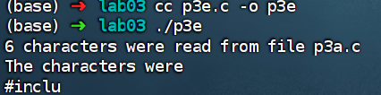

p3f.c -o p3f
./p3f

Exercise – Create and compile this exercise as p3f.c
The cat utility in Unix displays the contents of a given file on the text window. Write your own program to do this in C as follows:

The program should ask the user for the name of the file to be printed and read in the user’s response using scanf.
The program should then open that file.
The program should then read the entire file of text in blocks of 10 characters and write this to standard output using the byte level read and write functions below.
The program should then close the file and terminate.

Note that when there are no more characters available, the last call to function read will return a count less than 10. You can use a do-while loop which tests for this condition to decide when to terminate.

do {

n=read(fd, buffer, 10); /*Read 10 chars from file*/ write(1, buffer, n); /*Write chars to text terminal*/

} while (n==10); /* keep reading until n < 10 */

In order to receive your mark for the lab, please have the 6 C programs ready for inspection by a demonstrator at the end.

F code:

/* p3f.c */
#include <stdio.h>
#include <unistd.h>
#include <fcntl.h>
int main() {
char filename[256];
char buffer[10];
int fd, n;
printf("Enter filename to display: ");
if (scanf("%255s", filename) != 1) {
fprintf(stderr, "Invalid input\n");
return 1;
}
fd = open(filename, O_RDONLY);
if (fd < 0) {
perror("open");
return 1;
}
do {
n = read(fd, buffer, sizeof(buffer));
if (n < 0) {
perror("read");
close(fd);
return 1;
}
if (n > 0) {
if (write(1, buffer, n) != n) {
perror("write");
close(fd);
return 1;
}
}
} while (n == (int)sizeof(buffer));
close(fd);
return 0;
}

command

cc p3f.c -o p3f
./p3f

